**6) Explain in detail the heat maps and scatter plot and how to create them with example**

**(With the help of an example create one in tableau)**

**Heat Maps:**

**Definition**: A heat map is a graphical representation of data where values in a matrix are represented as colors. Heat maps are useful for visualizing the magnitude of values in a two-dimensional space, making it easy to identify patterns, trends, and areas of interest.

**Creating a Heat Map in Tableau:**

1. **Data Preparation:**

* Open Tableau and connect to your data source.
* Arrange your data in a matrix format with rows and columns representing categories or dimensions and the intersection values being the measure you want to visualize.

1. **Building the Heat Map:**

* Drag the required dimensions to the Columns and Rows shelves.
* Drag the measure you want to visualize to the "Color" shelf.

1. **Customization:**

* Adjust the color scale by clicking on the color legend and choosing a suitable color palette.
* You can also add labels, tool-tips, and adjust the formatting as needed.

1. **Example:**

* Suppose you have a data set with monthly sales data for different products. To create a heat map, you might place the products on the Rows shelf, months on the Columns shelf, and the sales measure on the Color shelf. The resulting heat map will show sales intensity across products and months.

**Scatter Plots:**

**Definition**: A scatter plot is a two-dimensional data visualization that uses dots to represent the values of two different variables. Each dot on the scatter plot represents an observation, and the position of the dot is determined by the values of the two variables.

**Creating a Scatter Plot in Tableau:**

1. **Data Preparation:**

* Connect to your data source and identify the two measures or dimensions you want to compare.

1. **Building the Scatter Plot:**

* Drag one measure to the Columns shelf and another measure to the Rows shelf.
* Tableau will automatically create a scatter plot with points representing the values.

1. **Customization:**

* Customize the appearance by adjusting the size, color, and shape of the marks.
* Add labels, tool-tips, and reference lines if needed.

1. **Example:**

* Let's say you have a data set with information about the height and weight of individuals. You can create a scatter plot by placing the height measure on the Columns shelf and the weight measure on the Rows shelf. Each point on the scatter plot will represent an individual's height and weight.

**In Tableau:**

**Prerequisites**: Superstore Data-source provided by Tableau, which includes three tables: orders, people, and returns.

**Orders Table**:

Columns: Order ID, Order Date, Ship Date, Ship Mode, Customer Name, Segment, Country/Region, City, State, Province, Category

**People Table**:

Columns: Regional Manager

**Returns Table**:

Columns: Returned

* Select Month in order date dimension and add it to columns and select order date from dimensions and drag it to rows.
* Select profit in measure and drag it on the color.
* Select Profit and drag it on the label.
* Select Marks to Square.

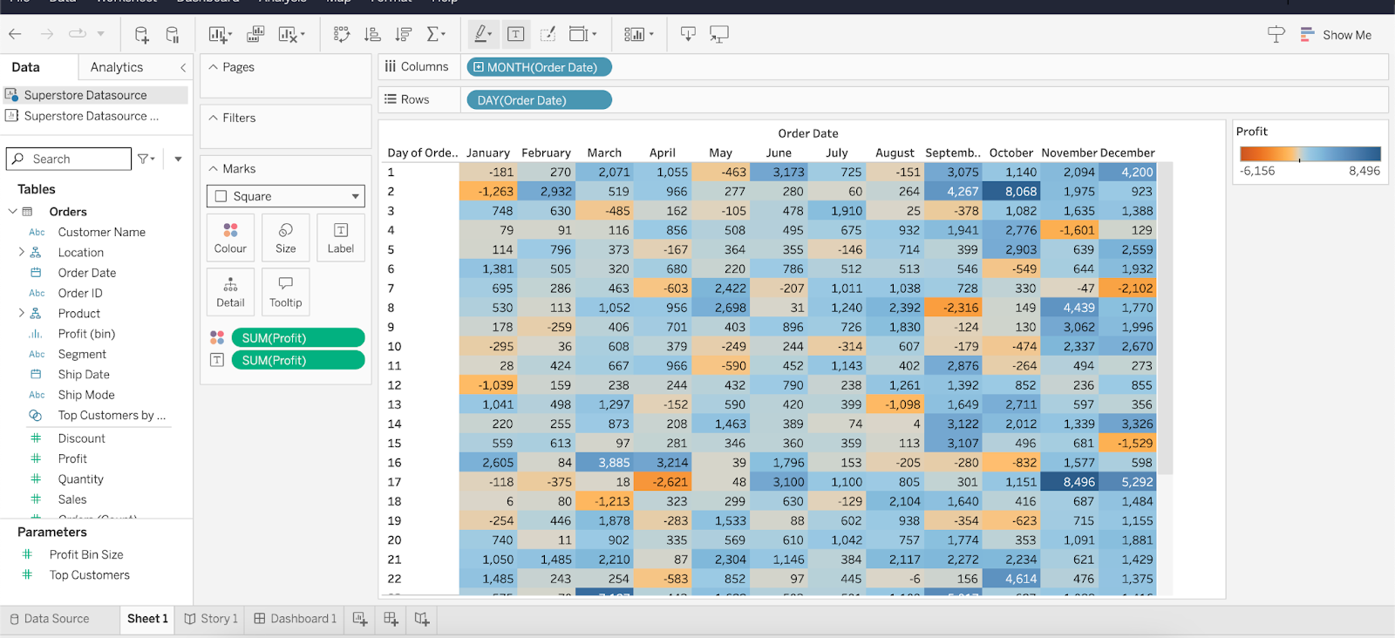

* For creating scatter plots. Select profit in columns and sales in rows.
* Select State/Province and drag it to detail.

